# Practical 1: Create chat application using either TCP or UDP protocol.

## Server Code

import java.net.*;

import java.io.*;

class server1

{

public static void main(String args[]) throws Exception

{

ServerSocket ss = new ServerSocket(7777);

Socket s = ss.accept();

System.out.println("Connected");

PrintStream ps = new PrintStream(s.getOutputStream());

BufferedReader br = new BufferedReader(new InputStreamReader(s.getInputStream()));

BufferedReader kb = new BufferedReader(new InputStreamReader(System.in));

while(true)

{

String str="",str1="";

while((str=br.readLine())!=null)

{

System.out.println(str);

str1=kb.readLine();

ps.println(str1);

}

ps.close(); br.close(); kb.close(); s.close(); ss.close();

}

}

}

# Client Code

import java.net.*;

import java.io.*;

class client1

{

public static void main(String args[]) throws Exception

{

Socket s = new Socket("localhost",7777);

DataOutputStream dos = new DataOutputStream(s.getOutputStream());

BufferedReader br = new BufferedReader(new InputStreamReader(s.getInputStream()));

BufferedReader kb = new BufferedReader(new InputStreamReader(System.in));

String str,str1;

while(! (str=kb.readLine()).equals("exit"))

{

dos.writeBytes(str+"\n");

str1=br.readLine();

System.out.println(str1);

}

dos.close();

br.close();

kb.close();s.close();

}

}

## Server Output

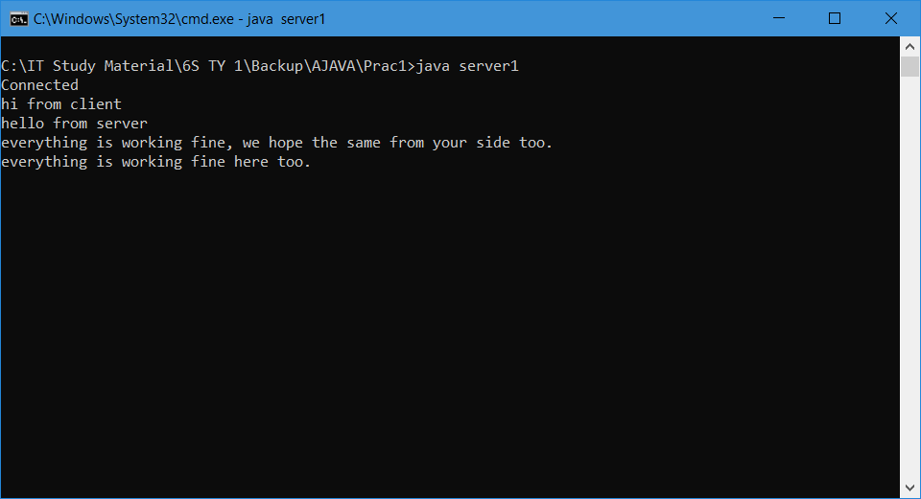

## Client Output

